Literacy support worksheet

2.1 Darwin and Wallace were co-conspirators

Pages 40–43

Evolutionary theory

1 What is a scientific theory?

|  |
| --- |
|  |
|  |

2 What did Charles Darwin and Alfred Wallace propose?

|  |
| --- |
|  |

3 Name two events that were considered to be acts of gods before evolutionary theory.

|  |
| --- |
|  |
|  |

4 Scientists can tell how old a fossil is based on which layer of rock they find it in. What is this technique called?

|  |
| --- |
|  |

5 How did Lamarck use giraffes as an example to show that if an organism changes during its lifetime in order to adapt to its environment, those changes are passed on to its offspring?

|  |
| --- |
|  |
|  |

6 How did Wiseman prove that Lamarck’s theory was wrong?

|  |
| --- |
|  |
|  |

7 Name two types of animals that have been domesticated through selective breeding.

|  |
| --- |
|  |
|  |

8 Name three of the features that ‘Darwin’s finches’ had in common.

|  |
| --- |
|  |
|  |

Word detective – Match the words

9 Match the scientists with the correct contribution they gave to evolutionary theory:

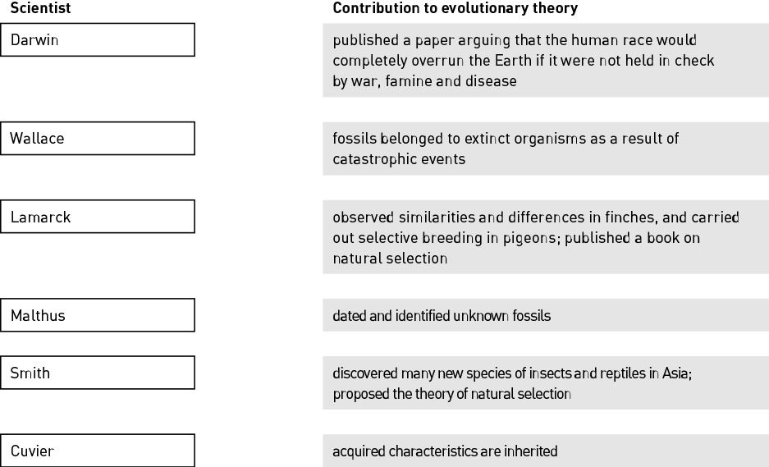

Literacy support worksheet

2.2 Natural selection is the mechanism of evolution

Pages 44–45

Natural selection

1 What is evolution?

|  |
| --- |
|  |
|  |
|  |

2 What is a gene pool?

|  |
| --- |
|  |
|  |
|  |

3 Write a number next to each of the sentences below to put them in order.

\_\_\_\_\_\_\_ When an organism is suited to the environment, it will be able to produce offspring.

\_\_\_\_\_\_\_ Mutations introduce new alleles into the gene pool.

\_\_\_\_\_\_\_ The offspring will have the same survival characteristics as their parent.

\_\_\_\_\_\_\_ Selection pressures cause some variations to survive and some to die.

4 The following image shows a population of red-beetles on a tree trunk. Red-beetles have either red, orange or brown wing colour.

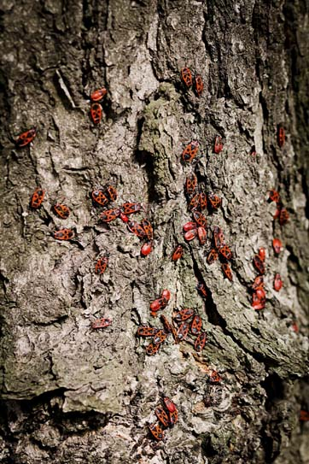

a Decide if each of the following descriptions is an observation or an inference. (Hint: Observations are facts and inferences are opinions.)

i ‘There are red-beetle individuals with different wing colours.’

|  |
| --- |
|  |

ii ‘Individual red-beetles that are most suited to their environment will survive.’

|  |
| --- |
|  |

iii ‘Red-beetle parents will pass on their wing colour to their offspring.’

|  |
| --- |
|  |

5 Fill in the blanks in the paragraph below.

In the situation of the ‘mutating moths’, when there was more \_\_\_\_\_\_\_\_\_\_\_\_\_\_\_\_\_\_, the trees became \_\_\_\_\_\_\_\_\_\_\_\_\_\_\_\_, which allowed the darker moths to \_\_\_\_\_\_\_\_\_\_\_\_\_\_\_\_\_\_\_. In areas where the pollution levels \_\_\_\_\_\_\_\_\_\_\_\_\_\_\_\_\_\_\_, light moths were selected \_\_\_\_\_\_\_\_\_\_\_\_\_\_ and dark moths were selected \_\_\_\_\_\_\_\_\_\_\_\_\_\_\_\_\_\_\_\_.

Word detective – Draw and label

6 Draw a labelled diagram to show how darker moths survived in the pollution and then how lighter moths survived as the pollution declined. Include the following terms in your diagram: natural selection, frequency, allele, selection pressure, declined.

|  |
| --- |
|  |

Literacy support worksheet

2.3 Different selection pressures cause divergence. Similar selection pressures cause convergence

Pages 46–47

Divergent and convergent evolution

1 Match each term with the correct example or description.

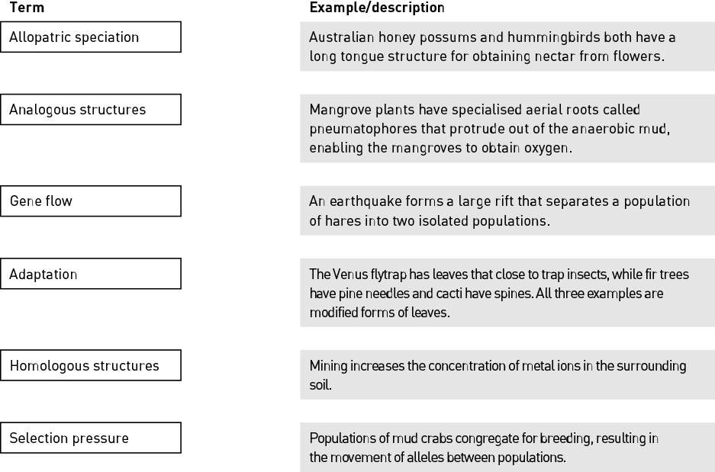

2 What happens when two populations become separated?

|  |
| --- |
|  |
|  |

3 Complete the following sentence:

‘If two groups of a species experience different selection pressures, \_\_\_\_\_\_\_\_\_\_\_\_\_\_\_\_\_\_\_\_\_\_\_\_\_\_.’

4 Use the following word list to fill in the blanks in the paragraph below.

Word list: gene flow, reproductively, diverged, isolated, variation, selection pressures, speciation

Within any population there is between individuals. A population is sometimes split into two and become from each other. This means there is no   
 . Each population is exposed to different . This changes the allelic frequency within each population and they eventually become   
 isolated and can no longer interbreed. Two different species are formed that have during the process of allopatric .

5 Monkeys and bats are examples of divergent evolution. They once shared a common ancestor, however different selection pressures have led to different species.

Fill in the table below to show the similarities and differences between monkeys and bats. Use your knowledge and Figure 2.10 in the student book to help you. Some of the possible answers have been done for you.

|  |  |  |
| --- | --- | --- |
| Similarities | Differences | Possible selection pressures |
|  | Monkeys have much longer fingers. | Monkeys needed to develop long strong fingers for climbing trees whereas bats needed short digits for landing on branches. |
|  |  |  |
|  |  |  |
| Monkeys and bats have small wrist or ankle bones |  |  |

Word detective – Draw a Venn diagram

6 Draw a Venn diagram to show the similarities and differences between monkeys and bats.

|  |
| --- |
|  |

Literacy support worksheet

2.4 Fossils provide evidence of evolution

Pages 48–51

Fossil evidence

1 Complete the following table by writing the correct terms and definitions in the spaces provided.

|  |  |
| --- | --- |
| Term | Definition |
| Fossil |  |
|  | The process of an organism becoming a fossil. |
|  | A fossil or an organism that shows the intermediate state between an ancestral form and that of its descendants; also known as a ‘missing link’. |
|  | A method that uses the amount of radioactivity remaining in the rock surrounding the fossil to determine its age. |
|  | An existing species of ancient lineage that has remained unchanged in form for a very long time. |
| Half-life |  |

2 Are older fossils found in deeper layers or more shallow layers of rock?

|  |
| --- |
|  |

3 Use the image of a fossil to answer the following questions.

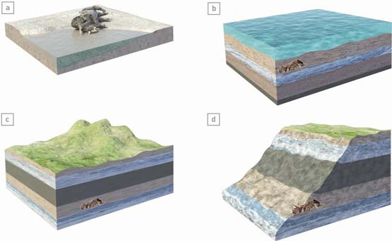

a Is this a relatively young fossil or a relatively old fossil?

|  |
| --- |
|  |

b Name one process that might help to reveal this fossil. (Hint: Use the information in Figure 2.13 in the student book to help you.)

|  |
| --- |
|  |
|  |

4 The time it takes for half the radioactivity to decrease is called the half-life. Scientists can use this to work out the age of a fossil.

Fill in the table below to show how much radioactivity decreases with each half-life.

|  |  |
| --- | --- |
| Number of half-lives | Radioactivity level decreases by |
| 1 |  |
|  | 25% |
| 3 |  |
|  | 6.25% |

Word detective – Sequencing

5 Write a number next to each of the sentences below to put them in order then draw the relevant diagrams for each one.

\_\_\_\_\_\_\_\_ Years of geological movement, weathering and erosion may eventually expose the fossil.

\_\_\_\_\_\_\_\_ Over millions of years, more sediment is deposited and the remains are transformed gradually into sedimentary rock.

\_\_\_\_\_\_\_\_ If an organism dies near water it has a greater chance of being covered by sediment.

Literacy support worksheet

2.5 Multiple forms of evidence support evolution

Pages 52–55

Evidence for evolution

1 Name two forms of evidence that support evolution.

|  |
| --- |
|  |
|  |

2 Fill in the blanks in the sentence below.

Frances Bacon noted at the beginning of the 17th \_\_\_\_\_\_\_\_\_\_\_\_\_\_\_\_\_\_\_\_\_\_\_\_\_\_\_ that the

\_\_\_\_\_\_\_\_\_\_\_\_\_\_\_\_\_\_\_\_\_\_\_\_ coast of South \_\_\_\_\_\_\_\_\_\_\_\_\_\_\_\_\_\_\_\_\_\_\_\_\_\_ and the west

coast of \_\_\_\_\_\_\_\_\_\_\_\_\_\_\_\_\_\_\_\_\_\_\_\_\_ looked as though they could fit together like the pieces of

a \_\_\_\_\_\_\_\_\_\_\_\_\_\_\_\_\_\_\_\_\_\_\_\_\_\_\_\_.

3 What is the name of the theory that describes the splitting and moving of land masses?

|  |
| --- |
|  |

4 Look at the map and fill in the table below to show where fossils were found on Gondwana.

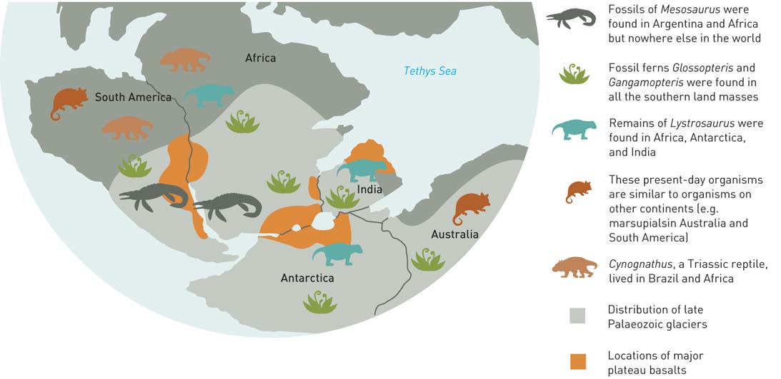

|  |  |
| --- | --- |
| Species | Location |
| Mesosaurus |  |
| Fossil ferns |  |
| Lystrosaurus |  |

5 Name three examples of vestigial structures (of any animal) that can be used as evidence to support evolution.

|  |
| --- |
|  |
|  |

Word detective – True or false

6 Decide whether each statement is true or false.

|  |  |
| --- | --- |
| Description | True or false? |
| At one point in time, all the land masses were joined as the supercontinent Gondwana. |  |
| Australia and Antarctica were once joined about 65 million years ago. |  |
| The early embryo of a horse first develops five finger-like digits that are then modified into a hoof in later stages of embryo development. |  |
| The forelimbs of different birds, whales and bats are examples of vestigial structures. |  |

Literacy support worksheet

2.6 DNA and proteins provide chemical evidence for evolution

Pages 56–57

Chemical evidence for evolution

1 What are proteins made from?

|  |
| --- |
|  |
|  |

2 Use the following word list to fill the blanks in the sentence below.

Word list: ancestor, nucleotide, evolutionary, organisms, differences

The more \_\_\_\_\_\_\_\_\_\_\_\_\_\_\_\_\_\_\_\_\_\_\_\_\_ in the \_\_\_\_\_\_\_\_\_\_\_\_\_\_\_\_\_\_\_\_\_\_\_\_\_\_ sequence in

\_\_\_\_\_\_\_\_\_\_\_\_\_\_\_\_\_\_\_\_\_\_\_\_\_\_\_\_\_\_ the more time has passed since they shared a common

\_\_\_\_\_\_\_\_\_\_\_\_\_\_\_\_\_\_\_\_\_\_ and the greater the \_\_\_\_\_\_\_\_\_\_\_\_\_\_\_\_\_\_\_\_\_\_ distance between species.

3 Name and describe two types of proteins.

|  |
| --- |
|  |
|  |

4 Complete the following sentence:

‘The more alike the two DNA sequences are, \_\_\_\_\_\_\_\_\_\_\_\_\_\_\_\_\_\_\_\_\_\_\_\_\_\_\_\_\_\_\_\_\_\_\_\_\_\_\_\_\_\_.’

5 Haemoglobin is a protein that transports oxygen around the body. The table below shows how the number of amino acids in the DNA sequencing of haemoglobin in animals is different to humans.

The smaller the number, the more closely related to humans they are.

|  |  |
| --- | --- |
| Vertebrate | Number of different amino acids to humans |
| Gorilla | 1 |
| Chicken | 45 |
| Frog | 67 |
| Mouse | 27 |
| Dog | 32 |

a Order the vertebrates based on how closely related they are to humans.

|  |
| --- |
|  |
|  |

b Which species are humans most closely related to?

|  |
| --- |
|  |
|  |

c What might have caused the single amino acid change between gorillas and humans?

|  |
| --- |
|  |

Word detective – Compare and contrast

6 Look at the phylogenetic tree below, including the amino acid sequence for Species A, B, C and D.

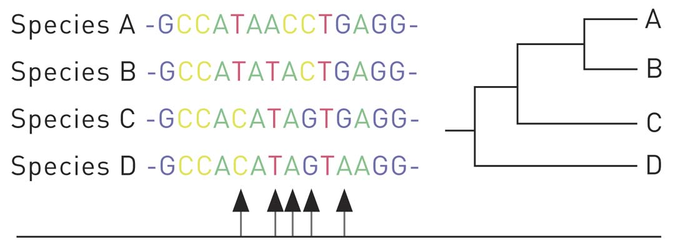

Compare and contrast A with each species. How is it different from other species?

|  |
| --- |
|  |
|  |
|  |
|  |

Literacy support worksheet

2.7 Humans artificially select traits

Pages 58–59

Artificial selection

1 What is artificial selection?

|  |
| --- |
|  |
|  |
|  |

2 Write the terms for the definitions in the table below.

|  |  |
| --- | --- |
| Term | Definition |
|  | Humans breed organisms with desirable traits, increasing the chance of the trait occurring in the next generation. |
|  | Subdivision of a species that has different characteristics yet can still interbreed; for example, different breeds of dog. |
|  | No longer wild due to being bred over many generations to produce a desirable characteristic such as tameness. |

3 Why is it not recommended to use antibiotics often?

|  |
| --- |
|  |
|  |

4 What is horizontal transfer?

|  |
| --- |
|  |
|  |

5 For each organism in the table below, identify the desirable trait that has been selected for and suggest why humans might have selected this trait.

|  |  |  |
| --- | --- | --- |
| Organism | Desired trait | Reason for trait being selected |
| L:\1. Publishing and Editorial\1. Product\Oxford Science\Oxford Science 10\3. Extras\6. Student worksheets\Artwork\4. Final jpgs\SW0214_01095-rm.jpg |  |  |
| L:\1. Publishing and Editorial\1. Product\Oxford Science\Oxford Science 10\3. Extras\6. Student worksheets\Artwork\4. Final jpgs\SW0215_01095.jpg |  |  |

6 List, in the table below, the advantages and disadvantages of selectively breeding bulldogs.

|  |  |
| --- | --- |
| Advantages | Disadvantages |
|  |  |
|  |  |

7 What is your opinion on selectively breeding bulldogs?

|  |
| --- |
|  |
|  |
|  |

Word detective – True or false

8 Read the statement and circle whether it is true or false.

a Selective breeding means that over many generations wild traits are lost. T or F

b New breeds can be formed through genetic mutations. T or F

c Bacteria becomes resistant to antibiotics when they are overused. T or F

d Golden Staph is one of the deadliest species of bacteria. T or F

e Artificial selection always breeds for healthy animals. T or F

f Super-bacteria is created via binary fission and horizontal transfer. T or F

Literacy support worksheet

2.8 Natural selection affects the frequency of alleles

Pages 60–61

Changes in alleles frequencies

1 What is sickle cell anaemia?

|  |
| --- |
|  |
|  |

2 Name some of the symptoms of sickle cell anaemia.

|  |
| --- |
|  |
|  |

3 What causes the haemoglobin to clump together in some people?

|  |
| --- |
|  |

4 Label the mutated haemoglobin proteins and the normal haemoglobin proteins, then match them to the normal and sickle cell red blood cells they produce.

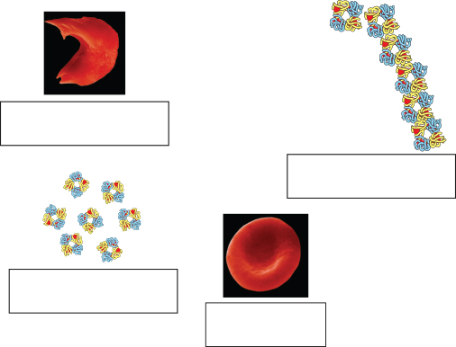

5 The following diagram shows the regions around the world where there are more cases of the sickle cell allele.

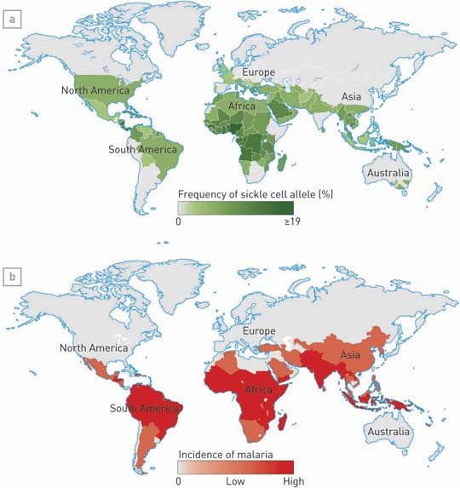

a Identify the selection pressure that results in an increase in the sickle cell allele in these regions.

|  |
| --- |
|  |

b What benefit does this mutation have to individuals in these regions?

|  |
| --- |
|  |
|  |

Word detective – Fill in the blanks

6 Use the following word list to fill the blanks in the paragraph below.

Word list: haemoglobin, amino, VAL, curved, CAC

A change in the nucleotide sequence causes a change in the acid sequence of haemoglobin. The sequence changes from CTC to within the haemoglobin gene and results in the amino acid glutamic acid (GLU) being substituted with . This causes the to clump together in a shape in people with sickle cell anaemia.